*** BOARD OF COMMISSIONERS MEETING ***

The Board of Commissioners of the Memphis Area Transit Authority will hold their Regular Board Meeting on Tuesday December 14, 2021 at 3:30 p.m. at Memphis Area Transit Authority, 1370 Levee Road.
For questions, please call Linda Eskridge at 901.722.7157.
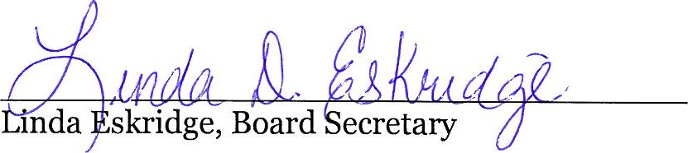

Date: October 25, 2021

To: Manager of Operations
City Hall

From: Linda Eskridge
Board Secretary

Please post this notice of the MATA Board Meeting. Remove it on Wednesday
October October 27, 2021

Thank you.

